

**Master of Science in Computing and Data Analytics**

**Business Intelligence**

**Project Report**

**Submitted to:**

**Dr. Hai Wang**

**Trishla Shah**

**Submitted by:**

**Gyaneshwar Rao (A00433014)**

**Shubham Chumber (A00433094)**

**Devvrat Deshwal(A00431503)**

Contents

Executive summary: 3

Introduction: 4

Analysis: 4

Data and Assumption: 4

SWOT ANALYSIS: 4

1) Strengths 5

2) Weaknesses 6

3) Opportunities 6

4) Threats 8

Cost-Benefit Analysis: 10

Conclusions: 11

# Executive summary:

In this project we have analyzed the sales data of the organization across Canada from 2009 to 2012. This analysis is on various factors such as Investment, Overall revenue, profit, mode of shipment and discount on products etc. We have analyzed to realize increase in the overall revenue or sales of the organization , authorities needs to improve the structure of shipment, storage of products under Furniture category, more focus on the sales of the technology products and excludes such products which are unable to convert sales into marginable profit.

By analyzing this data, we came on some important recommendations for the organization as given below-

* The organization should focus more on Ontario as it is best province across Canada in terms of sales and profit.
* The product under Technology category is giving highest profit (more than 40% of the total profit). Thus, they should treat them as their business driver.
* The organization requires to put more efforts on Nova Scotia and British Columbia as they are providing less profit on discounted products.
* Thy should use regular air as default shipping mode as it is the cheapest among all others.
* They should invest more on ‘Quebec’ Region as the profit percentage is relatively high.
* The organization should remove investing on the products which are using Jumbo Box as product container.

We have used Tableau and MS Excel to build dashboards, pivot tables and graphical representation of the data to make it clearer and more graspable. Thus, it will help the organization authorities to make decisions for the betterment of the organization in terms of sales and profit.

# Introduction:

In this project we have used sales Canada Dataset. This is a data of sales organization across Canada. The **business drivers** for this organization includes factors such as growth in overall sales, revenue and profit. Like others, this organization is also having a **Business performance metrics** also named as **KPI’s (Key Performance Indicators)** focuses on the growth of it in terms of sales and Revenue.

To evaluate the factors affecting the growth of organization we have done some analysis on subjects like Revenue, Net Income, Profit, discount offered by the organization, Mode of shipment, Product category, distinct types of product container, sales, Inventory, and orders.

# Analysis:

In this project we have analyzed the Sales Canada data to find out insights. On the basis of these insights an authority can be able to take the important decisions for the growth of the organization. We have used two major methods for Data analysis process as given below with Data and Assumption:

## Data and Assumption:

In this project, we have considered Sales Canada data, and which contains the following information of the organization as given below-

* Investment and total sales of the organization.
* Information regarding Orders placed across Canada such as order quantity, priority, date of shipment, etc.
* Details of products such as Category, unit price, sub-category, name, and product container.
* Cost related information such as profit from products, discount offered, Product base margin cost, etc.
* Shipment details such as shipping mode, date of shipment, cost of shipment.

There are some **Assumptions** taken while analyzing the data as following:

* The population of Ontario and Quebec is relatively same.
* The shipment cost of the product is paid by the organization.
* The quantity of products shipped in each turn is same for all mode of shipment.
* The count of order placed is directly proportional to the total sales of the organization.

## SWOT ANALYSIS:

Swot Analysis is basically a modern method to analyses the sales data based on four factors Strength, Weaknesses, Opportunities and Threats for the betterment of the organization.

The insights from the data through Swot analysis are given below categorized based on the four factors:

### 1) Strengths

* In the below image we can see that Ontario and British Columbia is the strength of the organization in terms of both sales and profit. Thus, they should focus more on these areas to enhance their business.
* We can also see that Manitoba and Quebec are having decent profit instead of less sales. Thus, they should perform desired actions to increase the sales in these areas to increase the profit.

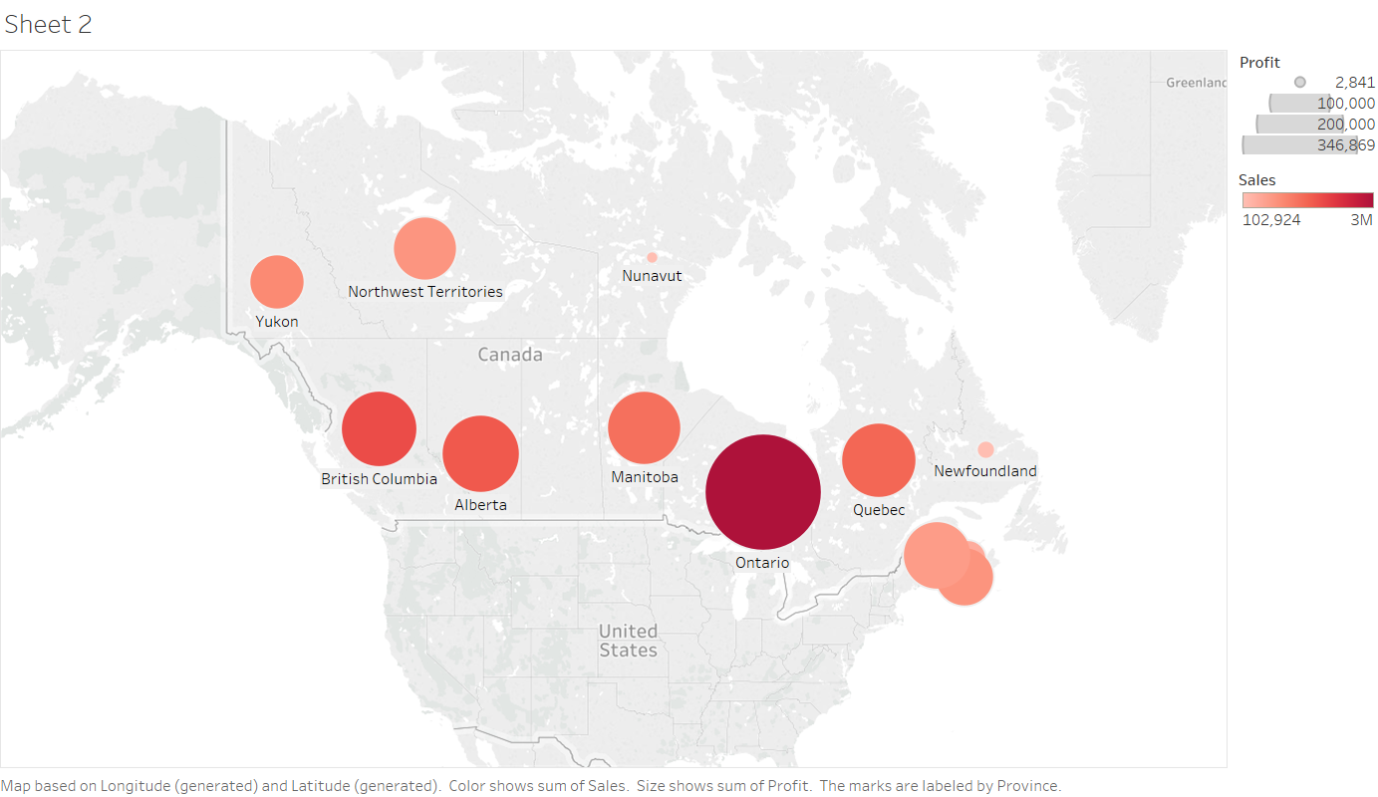

Figure : Sales and Profit across Regions

In the Below bar graph we can see that Products related to technology is a big strength for the organization as sales of such product is giving more profit instead of offering less discount from the seller.

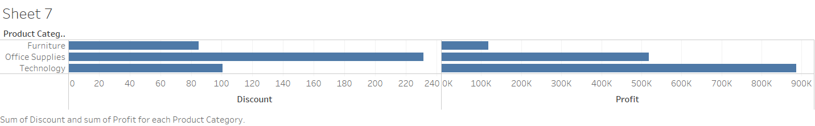

Figure : Product Category

### 2) Weaknesses

We found some weakness of the organization across some regions of converting sales into profit as given below:

* In the below graph we can see that both the regions are having approximately similar sales ratio but net profit of the Nova Scotia is far less in comparing with Northwest Territories regions in spite of offering more discount on the products.

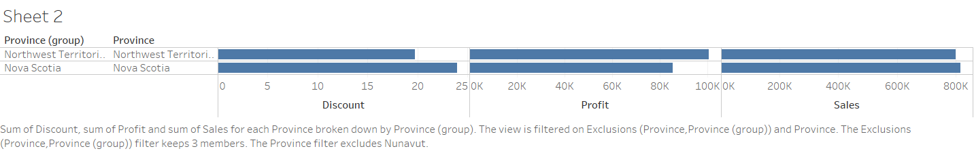

Figure : Nova Scotia is drawing less profit

* We can see the same weakness in the below graph for the region for British Columbia when comparing with Alberta.

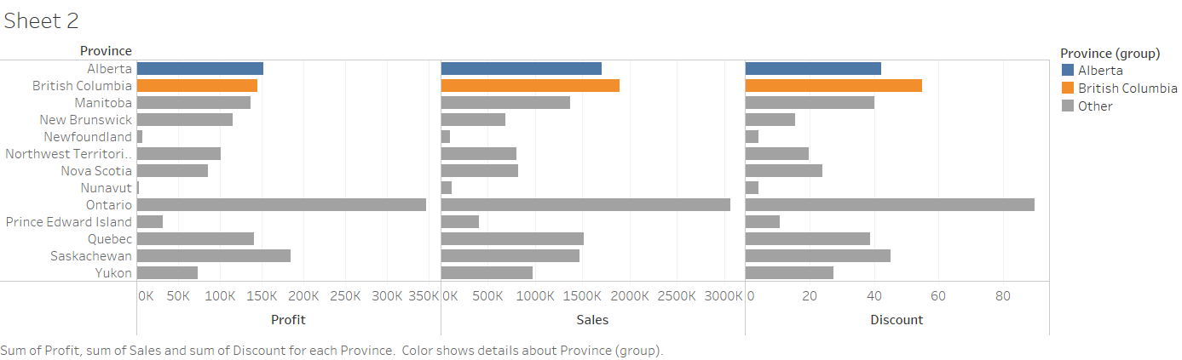

Figure : British Columbia is drawing less profit

### 3) Opportunities

* In the below graph we can see for the products shipped through Regular air is highest and the average shipment cost is lowest in all three. Thus, this is a big opportunity for the organization. As, this can enhance the profit margin to a good level

Figure : Regular Air as best shipping mode

Figure : Regular Air as Cheapest shipping mode

* As we can see in the below graphs that Quebec is having high percentage of profit and it is similar to Ontario in terms of population (number of customers) and business values. Thus, we recommend increasing the investment in Quebec to get more profit.

Figure : Quebec is having relatively high profit percentage

Figure : Quebec is having relatively low Investment

### 4) Threats

The major threat for the organization is the decrease in the sales from last couple of years and thus, causes a massive decrease in the revenue of the organization.

The below graph shows the year-by-year analysis of the overall sales decreasing from 2009 to 2011.

Figure : Year wise Decrease in the sales

We also found the negative profit from the sales of the products packed in Jumbo Box (Product Container). So, this is also a big threat as it is converting sales to profit even after providing discount.

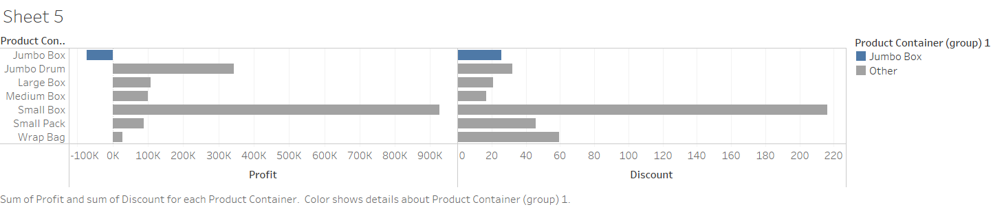

Figure : Negative profit from the products packed in Jumbo Box container

* We also found the negligible profit from the sales of the products packed in Wrap Bag (Product Container). So, this is also a big threat as it is converting sales to profit even after providing high discount.

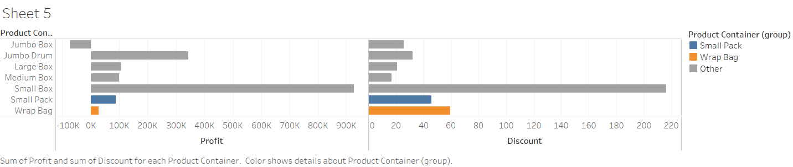

Figure : Low profit from the products packed in Jumbo Box container

## Cost-Benefit Analysis:

A cost benefit analysis is a process used by organizations to take the actions on the based of some insights for the overall growth in the revenue. The outcome of this process shows the Cost feasibility of the organization towards the sales of the products across various regions in Canada.

* In the Below bar graph, we can see that the products shipped by Regular mode is having highest number of orders as well as this mode is cheapest mode in terms of average shipping cost. Thus, Organization should ship their products in this mode of transport as it will increase the profit margin of the products

Figure : Regular Air as best shipping code

* In the below graph we can see that Products under furniture Category is very high in terms of sale as well as very low in terms of profit. Thus, Organization can exclude these items as these products consumes a high managing and storing cost due to their high volume.
* On the other hand, we can also see that Average sales of the Products under Technology Category is very high in terms of sale as well profit. Thus, organization can increase the stock of the products to enhance the overall profit.

Figure : Technology as best products among all in terms of sales and profit

# Conclusions:

From the overall analysis we have concluded that there are some issues due to which organization is lacking in terms of sales and profit. We have some **recommendations & Future steps** regarding them as listed below:

* The organization should deal more in products comes under Technology as they are having a highest ratio of Sales vs Profit.
* They should ship their item through Regular Air mode as it is cheapest among all. Thus, increasing the profit margin of the product.
* There are some regions like Alberta, Monitoba and Quebec where Average profit of the products is good, but sales is down. Thus, organization should take appropriate actions in these regions to increase the sale.
* There are some regions like Nova Scotia and British Columbia where they are offering very high margin discounts on the products results in decreasing the overall profit. Thus, they should drive some alternative approach to increase the sale.
* The effective cost of shipping through Delivery Truck is very high. Thus, they should try other mode of shipping to reduce the cost of shipping.
* The overall sales of the organization had a drastic drop from year 2009 - 2011
* The products packed in Jumbo box and Wrap bag is having negative and negligible profits respectively. Thus, they should exclude the products which involves these two containers.
* Organization is spending a lot on storing products coming under Furniture category thus, they are not providing profit even after a huge amount of sales. Thus, they should pay a special attention on this these types of products are responsible for more than 40% of the total sales.